# Name – Mahi

# UID – 23BIS70030

# EXPERIMENT – 12

# AIM - Concurrent Ticket Booking System with Seat Locking and Confirmation

## Objective

Learn how to implement a ticket booking system in Node.js that handles concurrent seat reservation requests safely using a seat locking mechanism. This task helps you understand how to manage in-memory state, handle concurrent access, and design a system that prevents race conditions during booking

**CODE:**

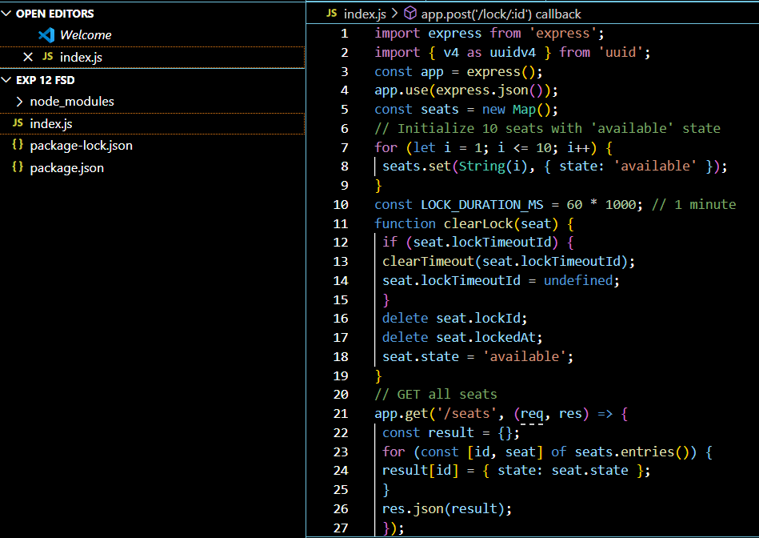

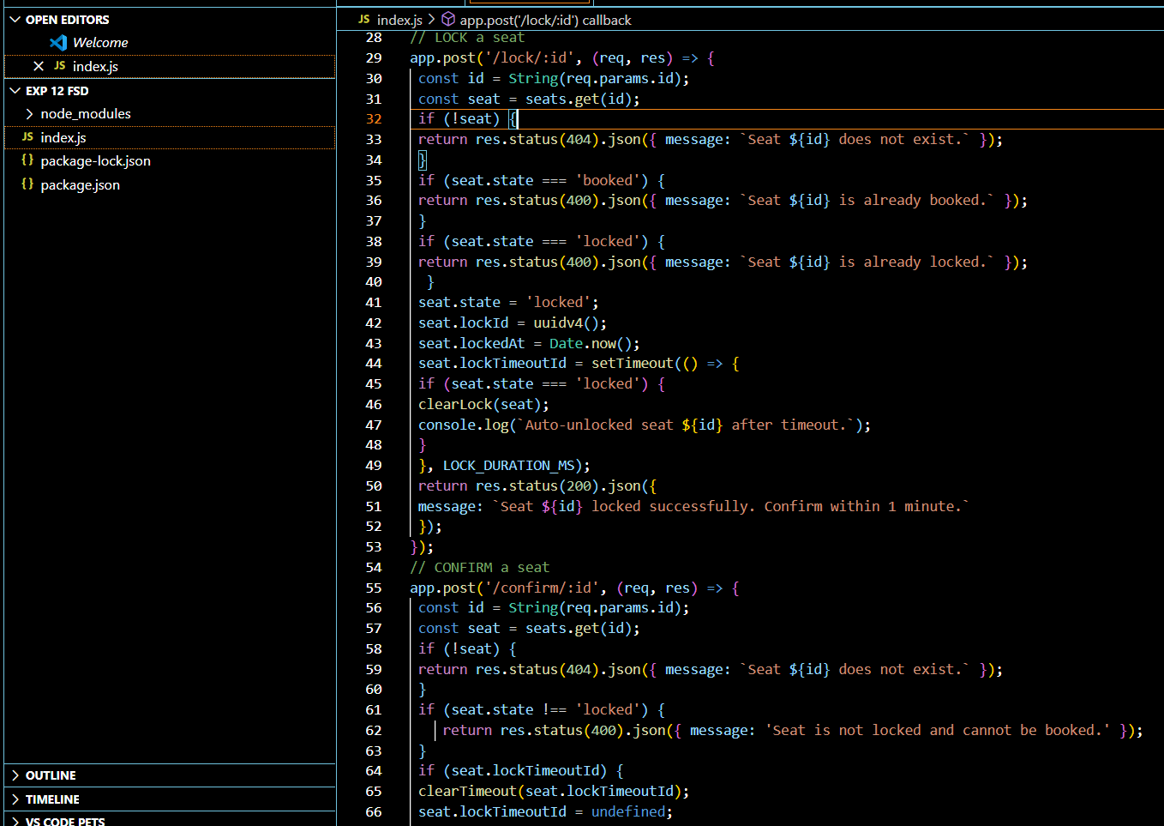

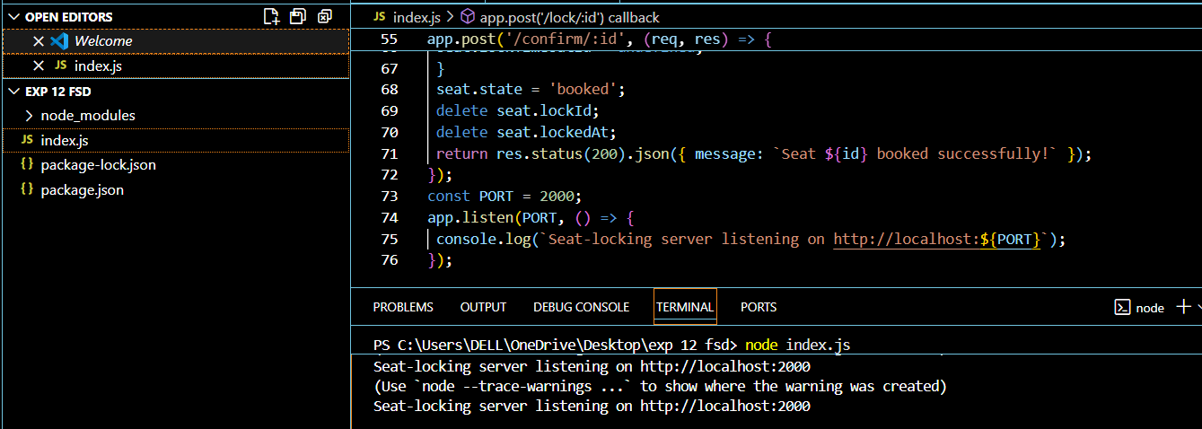

OUTPUT:

